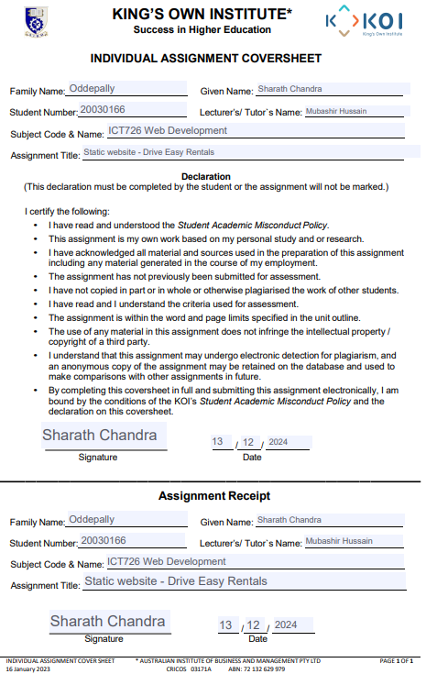

Table of Contents

Introduction: 3

Overview: 3

Design Decisions: 3

Challenges faced during development: 3

AI Assistance Declaration: 4

Accessibility and Usability: 4

Steps taken to ensure the website is responsive and user-friendly across different devices. 5

Screenshots of website: 6

Reflection 10

# **Introduction:**

Hello from Drive Easy Rentals, the centre for good quality, reasonably priced, reliable Drive Easy rentals, whether you're organizing a work trip family vacation or relax during the weekend Our goal is to make the rental process easy and convenient. We have a wide range of vehicles, from economy cars to luxury sedans and small SUVs, to accommodate every need and price range. Dedication to customer happiness honest price and first-class service this makes us a great choice for travellers looking for a hassle-free Drive Easy rental experience.

## **Overview:**

The goal of the Drive Easy Rentals website is to provide a comprehensive and accessible platform for all our services. Easy navigation links to the About Us, Services and Contact pages are included on the home page. Along with a main image slider showing our most popular rental options, Drive Easy Rentals, our company and the team behind our beliefs are featured on the page. The "About Us" page will show you rental options, how to book, insurance, GPS rentals and other additional services. In addition to our contact form and location information the contact page also allows customers to contact us quickly and easily. Each page has been carefully designed to provide a smooth browsing experience. Guarantees that customers can quickly find the information they need and make informed decisions about their Drive Easy rental needs.

## **Design Decisions:**

To improve user experience, the Drive Easy Rentals website design is focused on usability and simplicity. The main image on the homepage instantly engages visitors and effectively communicates our brand message. It reinforces our dedication to providing high quality service. Users can instantly find what they're looking for with clear navigation options at the top. Makes it easy to access various channels Includes home page, topics, services, and contacts. The booking form is simple and clear with extensive input fields and drop-down menus for selecting vehicle types. Reduce friction it is also prominently displayed on the booking page to make booking easier. These design choices make the website flexible and easy to use across platforms. Emphasis is placed on attractive appearance. Easy navigation and quick access to essential services.

## **Challenges faced during development:**

A number of problems arose during the creation of the Drive Easy Rentals website. The main challenge was responsive design. This requires smooth scaling across screens and devices, ensuring booking forms are efficient and accessible on desktops, tablets and mobile devices. This requires careful consideration of the layout touch interaction and functionality another issue is integrating Hero Image Slider without sacrificing load times. This requires customizing the script and image content. Complexity is also increased by the need to accommodate the diverse content needs of pages such as About Us and Services and maintain a consistent brand and aesthetic across the website.

# **AI Assistance Declaration:**

Several AI techniques were used to speed up the creation of the Drive Easy Rentals website, initial layouts and mock-ups for the pages. It was quickly created using design tools like Canva and Adobe's AI capabilities, then customized to fit the brand's unique look and feel by adding the company logo, colour scheme, and visual elements. The first hero images and icons created by DALL-E and other graphic design programs. It was modified to fit the brand identity by adding company-specific elements and improve the content including the default content for the page. These pages are then personalized with a mix of customized content that reflects your brand's voice and Special service offers. These AI capabilities enable developers to create unified websites. It is beautiful, attractive and has a lot of content at a glance.

# **Accessibility and Usability:**

**Accessibility:**

Accessibility was a top priority when designing the Drive Easy Rentals website to ensure that everyone Even people with disabilities can use it. This site can be read and navigated by people using screen readers or other assistive devices. Because the design meets the requirements Add features like subtitles for movies. Alternative text for images appropriate use of ARIA labels to provide meaningful experiences for visually impaired people the ability to adjust text size and high-contrast colour schemes are included to improve readability for the visually impaired. Ensures the use of websites for people with mobility disabilities with an emphasis on keyboard navigation. This allows users to access all features without using a mouse.

**Usability:**

To provide a smooth and efficient user experience. Usability is therefore a key element of the Drive Easy Rentals website design. Simple menu structure. User friendly layout and breadcrumb navigation Allows users to search for various routes. Easily on the web Large, accessible fields and labels are included in the form design to reduce user errors and speed up the booking process. For example, the booking form has easy-to-follow instructions and labelling. clear Instead of using a mysterious code Error messages that provide helpful hints The visual difference between buttons and subtitles makes them easy to click and available on a variety of devices.

## **Steps taken to ensure the website is responsive and user-friendly across different devices.**

Drive Easy Rentals uses a mobile-first design strategy from the beginning to ensure the website is responsive and accessible across devices. This approach focuses on providing a smooth user experience on small screens before gradually improved design to be larger. The website uses a flexible web structure that dynamically adapts to your device's screen size. This allows for efficient rearrangement of content. By carefully defining breakpoints using media commands, the website can then change its configuration and optimize its content for computers and tablets. With touch-friendly features like larger buttons and more straightforward drop-down menus that improve usability on smartphones. This strategy ensures that booking forms, hero images, and navigation menus are available and working across all platforms. Images and other multimedia elements Optimized for faster loading to improve performance on mobile websites with these efforts every visitor receives a smooth, responsive and engaging experience, ensuring a uniform and intuitive user experience across multiple devices.

# **Screenshot of a website:**

Home page:

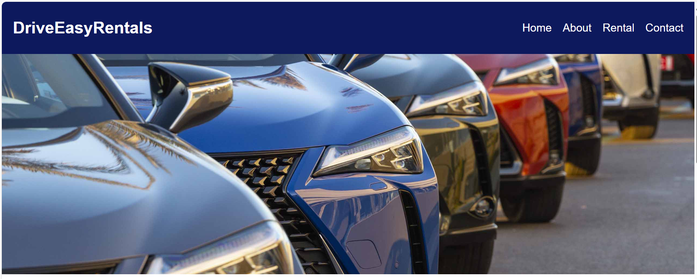

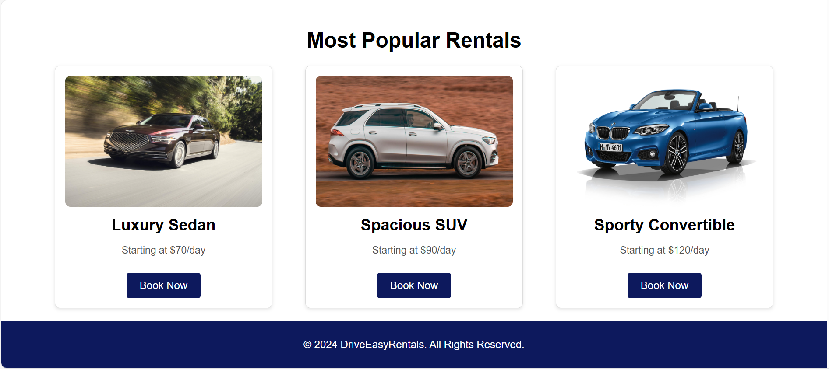

About us page:

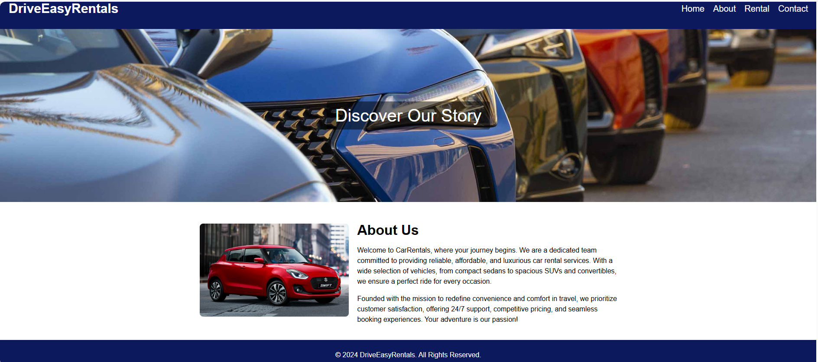

Rental page:

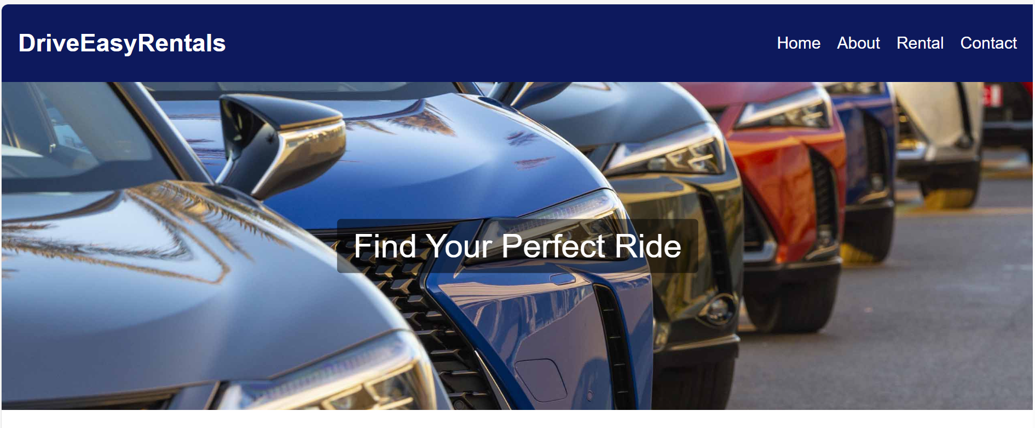

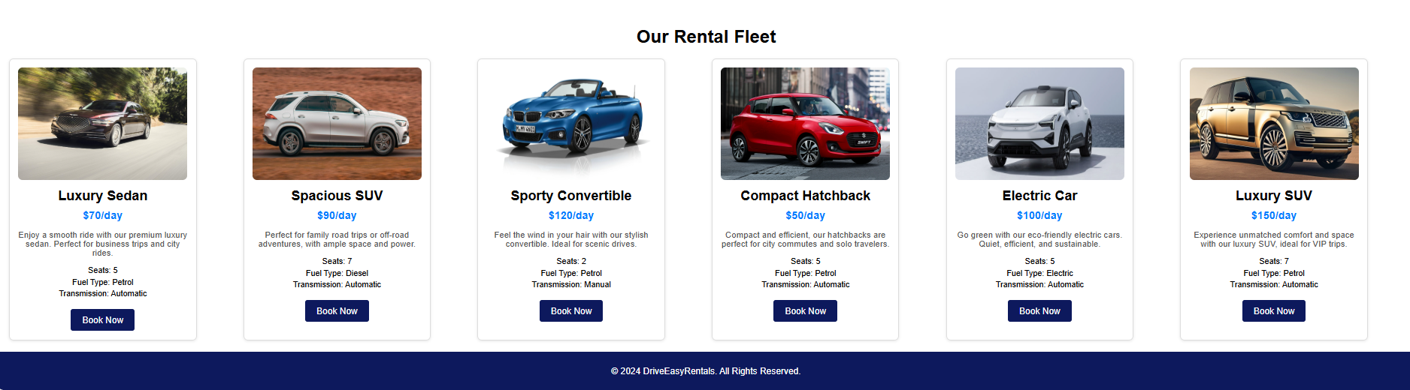

Booking page:

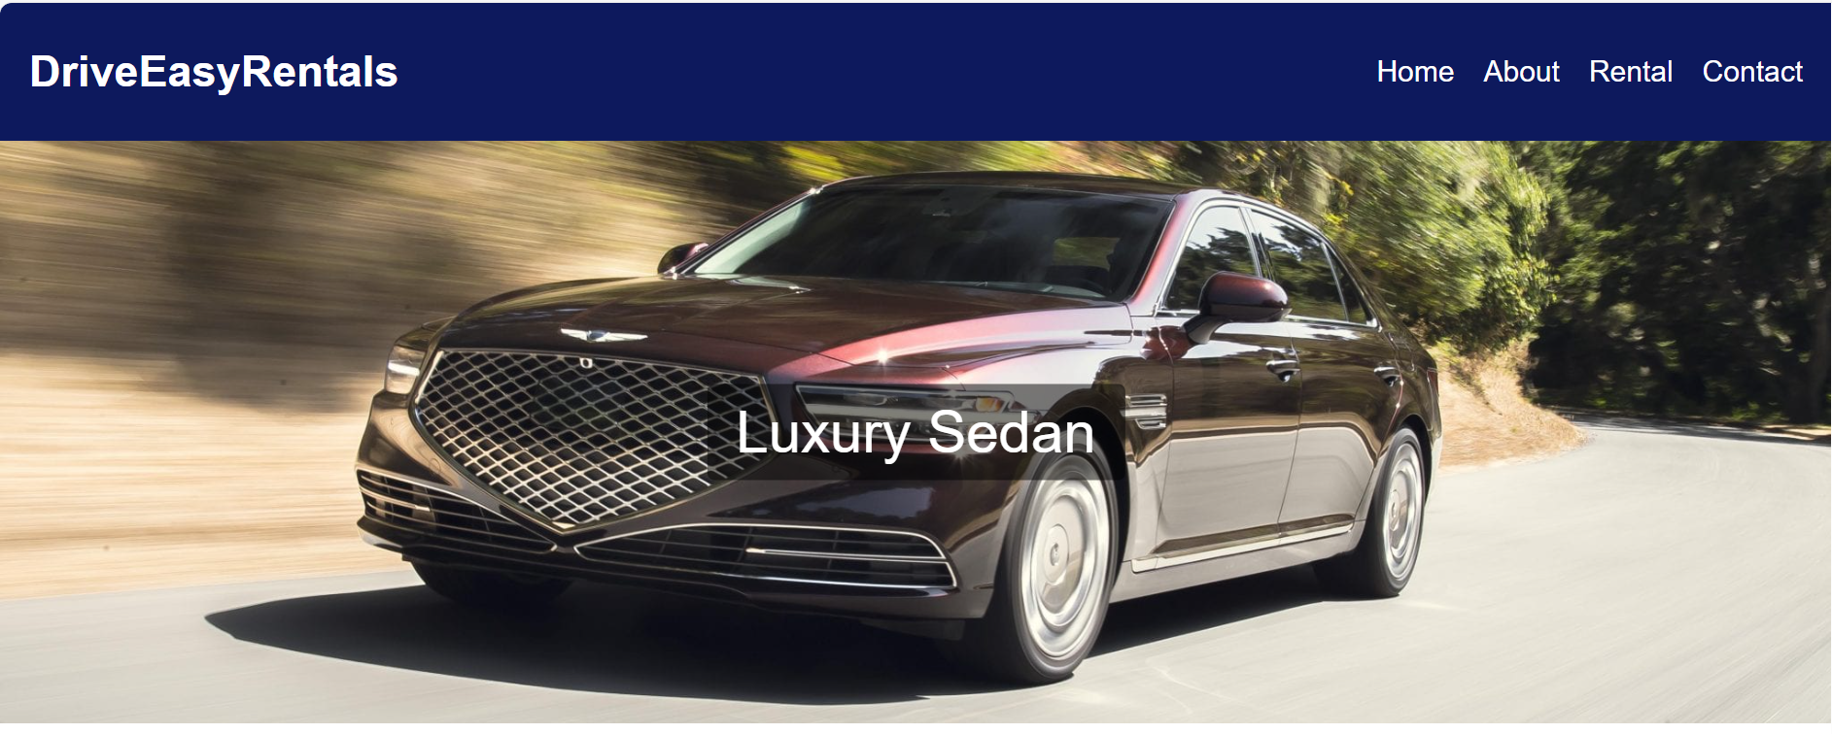

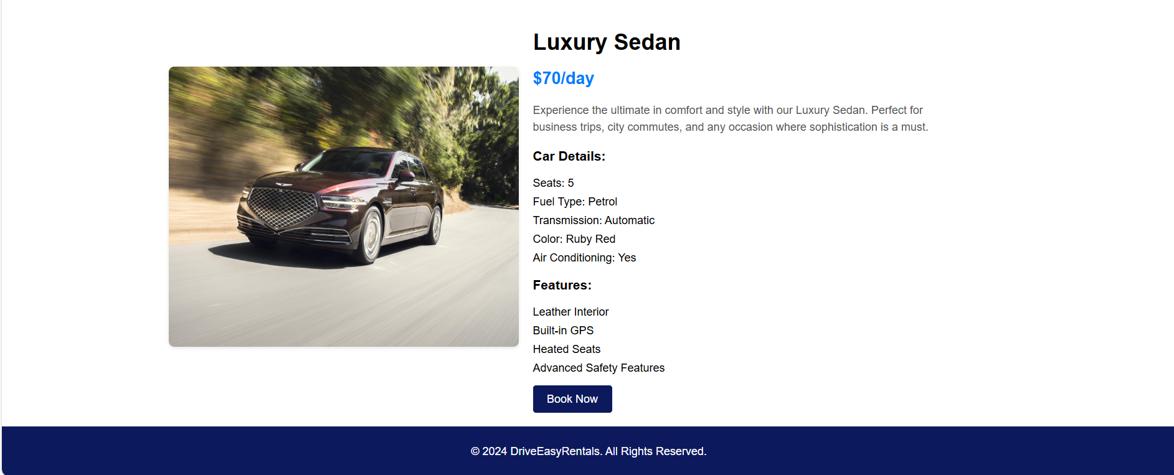

Confirmation page:



Contact page:

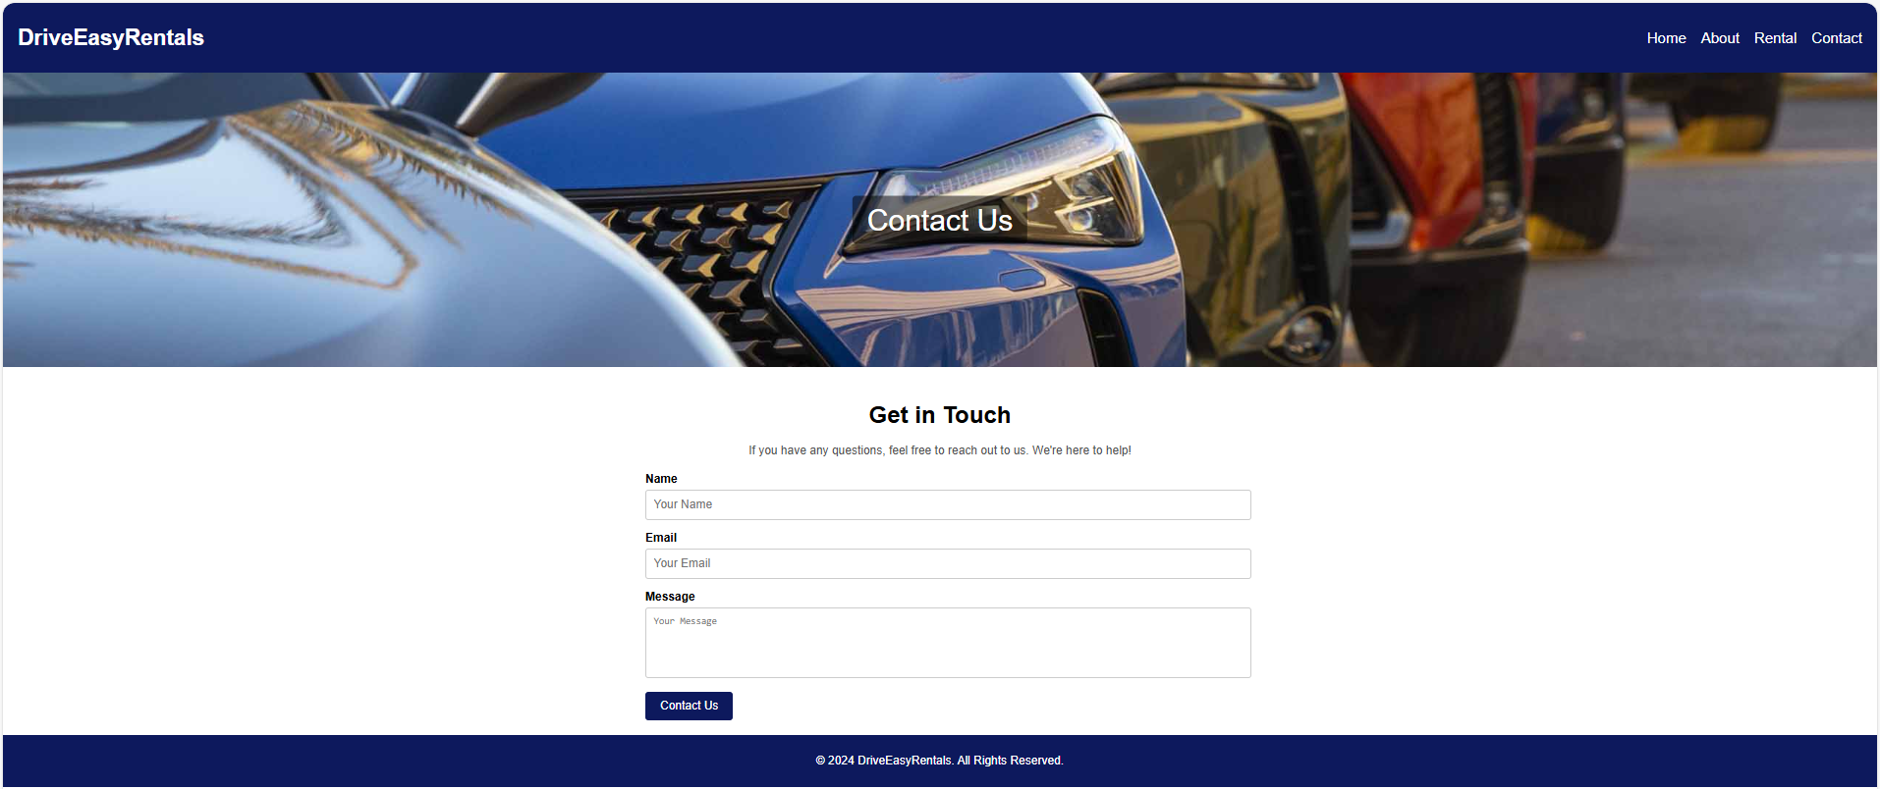

# **Reflection**

Looking at the entire process of creating the Drive Easy Rentals website, it is clear that the quality and efficiency of the project has been greatly improved through the use of AI technology. First of all, AI plays a key role in providing basic support. Canva and Adobe's AI capabilities help. Allows for quick creation of layouts and mock-ups this greatly speeds up the design process. This is especially helpful in ensuring that your website's visual elements match your brand identity from the start and maintain design consistency across departments. These drafts provide a solid foundation for later improvements. In addition to saving time, it is essential that the AI-generated typography matches the brand voice and provides accurate information about the services offered. The development team can focus more on the finer elements of the project. Such usability and ease of use this is thanks to a more efficient workflow made possible by this iterative process. It starts with AI tools and later refines,

This experience taught me how valuable artificial intelligence is to web development. AI technology can effectively increase productivity. This makes it easier for engineers to take on challenging tasks. By providing insights Reducing time spent on tedious tasks Not only does it speed up the process. But it also improves the quality of the final result. Using AI for content creation guarantees accuracy and consistency across site content and also reduces the amount of Time required for preliminary drafting Website responsiveness and on-device usability, which is increasingly important in today's multi-device online environment. This is guaranteed by a mobile-first design strategy. Which is guided by AI tools.

I learned the value of fusing cutting-edge AI technology with traditional design thinking throughout the process of building the Drive Easy Rentals website. The goal was to use technology to develop creative thinking and problem-solving skills. This ultimately results in a more efficient user-centred development process. In addition to providing technical assistance, AI tools promote a more dynamic and collaborative work environment. AI technology can automate certain tasks at every stage of a project. From design to use and provide insights into user behaviour setting new standards for future online projects. This combination of AI and human creativity creates websites that are not only beautiful but also pleasing. But it's also incredibly useful, accessible, user friendly.